Story Plot Worksheet
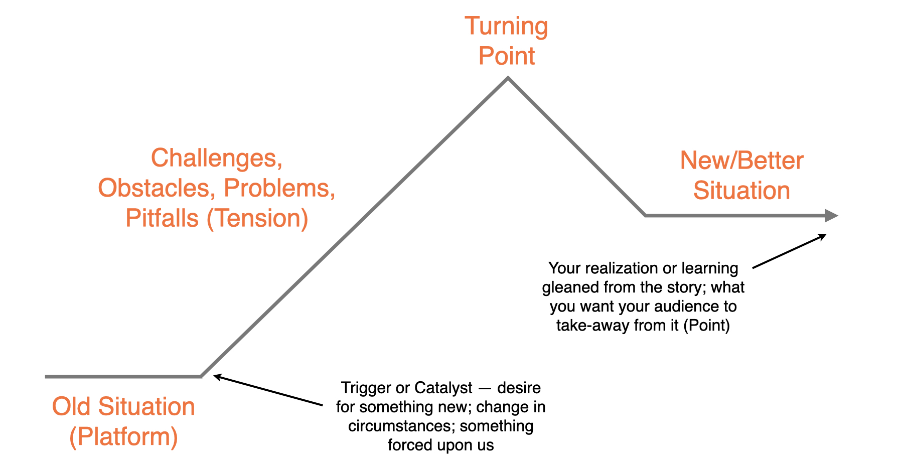

Old situation, starting point for people in story
(Platform)
Catalyst, trigger that sends characters on a new or different path
Challenges, problems, obstacles experienced along the way (Tension)
Turning point, tension resolution (or how things went from bad to worse if no turning point)
New situation after turning point (or what the future should be if no turning point)

Learning or realization taken from experience
(Point)

